

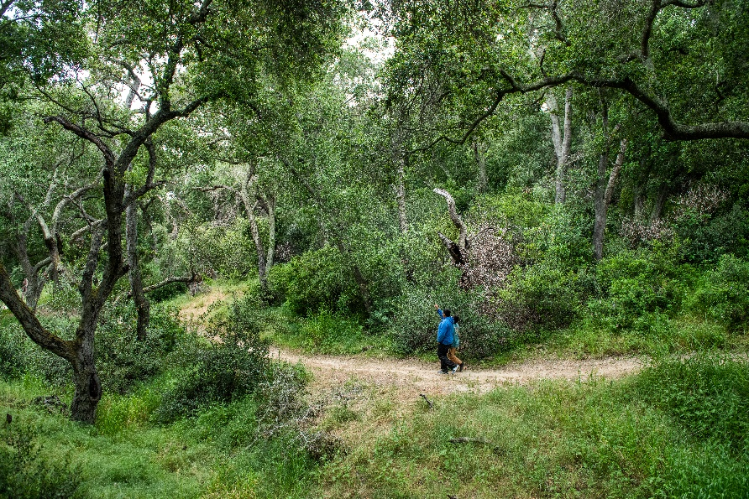

**Why Leaves Fall**

**Saturday, May 3, 2025**

**9 to 11 a.m.**

O’Neill Regional Park

30892 Trabuco Canyon Rd.

Trabuco Canyon, CA 92678

For more information:

**(949) 923-2260 or email oneillpark@ocparks.com**

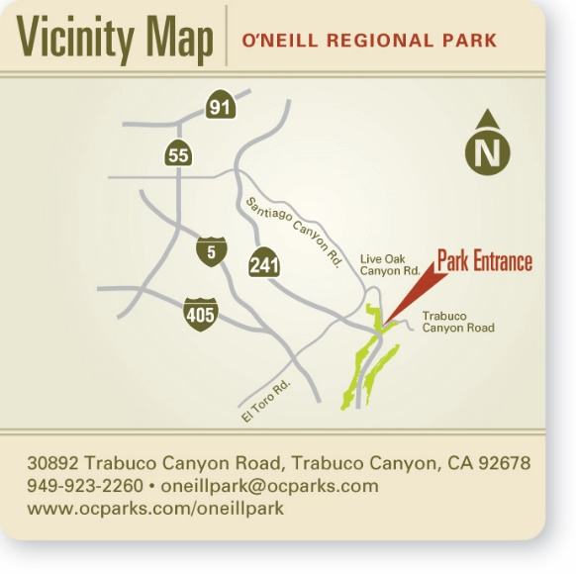Shape

Join an OC Parks volunteer naturalist to learn why leaves fall and other fun woodland facts at O’Neill Regional Park. This program is designed to provide access to nature for children with disabilities, especially those with mobility challenges. Activities are geared for ages 3-7 and families are welcome to join!

Take a walk on a level trail through the shady Oak Grove Day-Use Area while participating in a nature scavenger hunt. If time allows, we will venture a short distance on the Arroyo Trabuco Trail, then return to the amphitheater. The total distance for the walk is less than 1 mile. At the amphitheater, children will join in a themed craft, which will provide a sensory experience for each participant.

Parents must accompany their children and provide assistance as needed. Volunteers are available during the program, should you have questions or concerns.

Advance registration required.

Event is free. Parking is $5 per vehicle.